**Assignment 15.1**

**Problem Statement:**

Perform wordcount operation in local mode (In windows environment). Share the code, explain the execution steps, and attach the output screenshot.

**Solution:**

**Program:**

**Driver Class:**

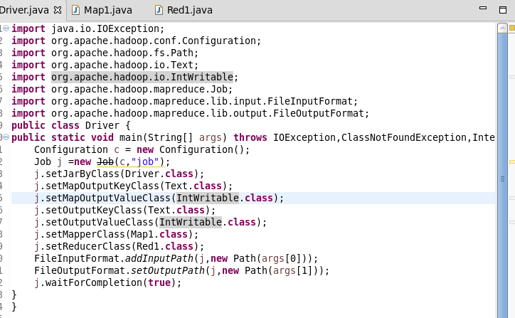

**Mapper class:**

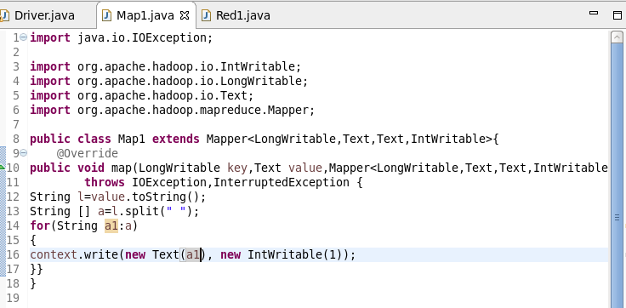

**Reducer class:**

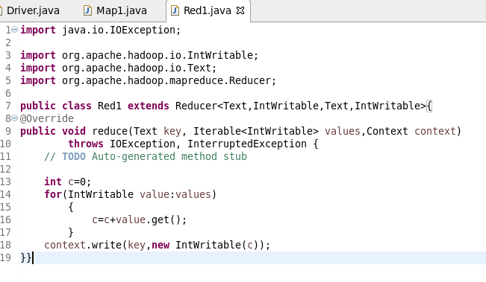

**Running jars and output:**



